**Game Design Studio Two**

**“Mowdown”**

**Team Four**

Report for Sprint Four

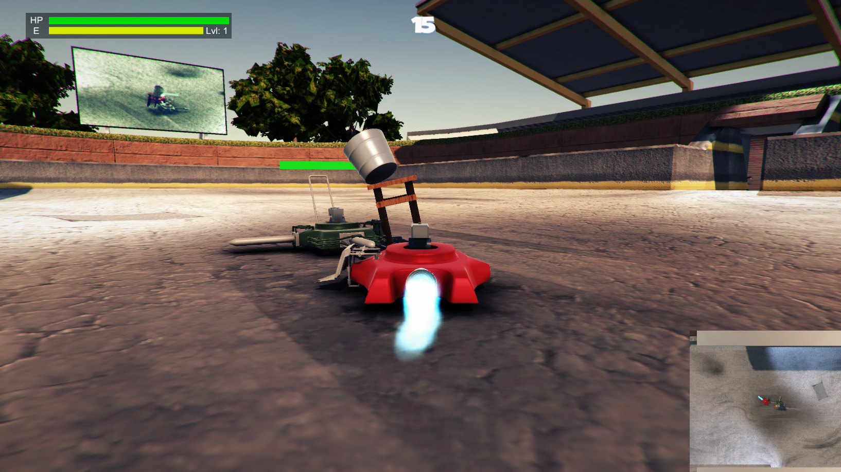21 / SEP / 2015 – 11 / OCT / 2015

**Team Members:**

Matthew Carver –12028130

Deinyon Davies – 11688025

Robert McClelland –11743693

Dinh Bao Anh (Brendan) Vo – 11437237

The most honoured Master of the Scrum,SirJesse Walker – 11729631

**OVERVIEW**

*Mowdown* is a ‘Demolition Derby’ or ‘Battle Bots’ style videogame, created by (in ascending alphanumeric order) Matthew Carver, Deinyon Davies, Dinh Bao Ahn (Brendan) Vo, Robert McClelland , and Jesse Walker.

Players customize one of several domestic **lawnmowers** by means of attaching defence appliances and weapons that have been unlocked and purchased by the player by means of in-game experience points and currency. Players compete against at least one autonomous opponent – a strategically formed battle-mower – as if both are controlled via Remote Control (R.C.).

Sprint Four sports several new features, bug fixes and enhancements, including (but not limited to): Particle effects for certain attachments, New level hazards, A 2 player split screen mode with xbox 360 controller support, Analytics was re-implemented, several new attachments and improved Artificial Intelligence.

**SPRINT PLAN AND EXECUTION**

Sprint Four of Project Mowdown set out to implement Thirty-Two discrete new features including (but not limited to): bug-fixes, Multiplayer, improved Artificial Intelligence, improved User Interface, Sound effects, a sleeker looking UI, Attachment Particle effects, vehicle attachment modelling and implementation. These thirty-two task items were identified in the initial Sprint Meeting.

As of the preliminary Sprint Meeting, the Sprint Log proposed a **total** **estimated** investment of **5,220 minutes** – 2830 minutes more than the estimated investment for Sprint Three – with an estimated **median** task duration of **80 minutes**. The sprint would optimistically be completed in 3,320 minutes.

This sprint focused largely on delivering new content for the users. In this endeavour we created four new attachments, as well as repurposed some of them to be hazards on the new map. We also implemented a multiplayer mode as some play testers expressed interest in combating their friends.

**SPRINT THREE PARA:** During the execution of the scrum, 2 critical and prerequisite tasks became apparent, which were completed and appended to the Sprint Log when necessary. The auxiliary tasks assumed an additional estimated duration of 80 minutes, expanding the **total** **estimated** sprint workload to **2,390** **minutes** (39 hours).

At Sprint finalisation, the Sprint Log totalled thirty-three expected and unexpected tasks. The team observed a **total** **logged** **workload** of **2,390 minutes** (~40 hours). **TO BE EDITED:** Twelve tasks stood incomplete or uninitiated at the time of sprint closure.

**SCRUM MEETING LOGS**

**21 / SEP / 2015**

5:00pm – 7:00pm

**Location**: UTS Building 11, Game Design Studio Laboratory

**Members present**: Brendan, Deinyon, Jesse, Matthew, Robert

The team identified backlog items and discussed time estimates.

**22 / SEP / 2015**

9:00pm – 10:00pm

**Location**: Online Group Discussion

**Members present**: Deinyon, Jesse, Robert

The team discussed new damage calculations using impulse. A new feature implemented in unity 5.2. Team also discussed complete update to 5.2 due to lighting bugs encountered in previous versions.

**27 / SEP / 2015**

7:00pm – 9:00pm

**Location:** Online Group Discussion

**Members present:** Deinyon, Jesse, Robert

The team discussed how new attachments are currently added to the store and how the AI uses these attachments. This meeting was set up so as to better educated the three programmers as they were working on intersecting systems without enough communication.

Once the meetup was completed the team was able to work on each other’s parts in case one of them was unavailable or was having difficulty fixing any bugs.

**07 / OCT / 2015**

**Location**: Online Group Discussion

**Members present**: Matt, Jesse, Robert

Discussed and stats of current attachments, the ‘standard’ level and how powerful various new attachments should be. This meeting focused on determining the new stats for all the attachments as the old stats were unsuitable with the new damage calculation system.

**BURNDOWN CHART**

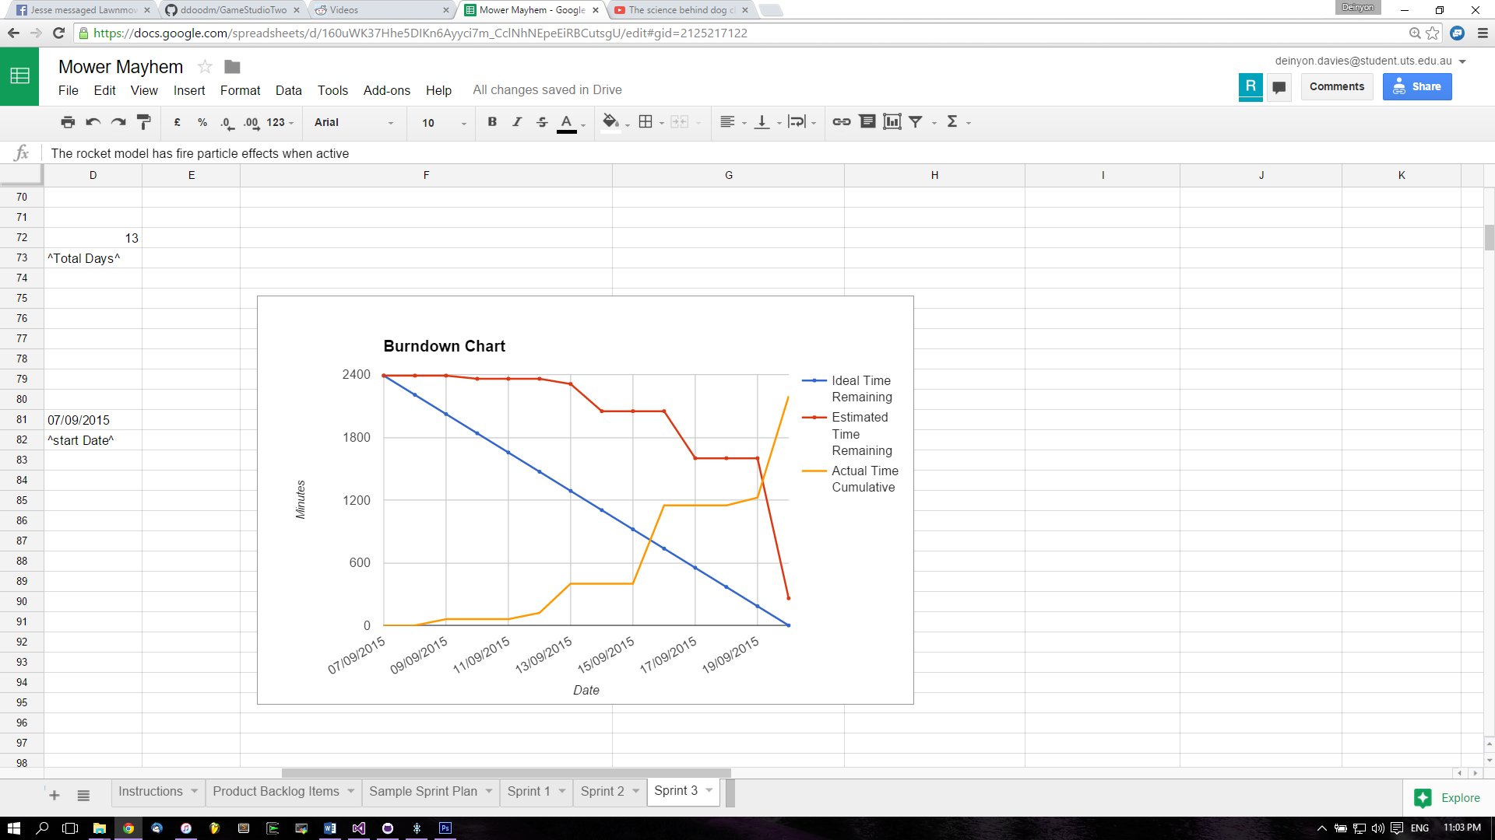

**REFLECTION**

Due to the extra week we had to work on this sprint the team attempted to add several more tasks to get as much done as we could. Unfortunately this seems to have caused more of an overestimation of work required rather than an actual increase in completed work. While the tasks completed in this sprint are large and contribute greatly to the final product, with the time we had we probably could have completed much more. The team also went into ‘holiday mode’ over the break and very little work was done during half of the sprint. While we did catch up again at the end of the holidays this shows poor commitment to the project. Despite this we believe that mowdown is progressing nicely and expect to have a very fun game at the end of the semester.

**SPECIAL CIRCUMSTANCES**

N/A

**Sprint Backlog**

|  |  |  |  |  |  |  |  |  |  |  |  |  |
| --- | --- | --- | --- | --- | --- | --- | --- | --- | --- | --- | --- | --- |
| **User Stories** | **Acceptance criteria** | **Assigned to** | **Order** | **Task** | **Esimated Time** | **Minimum Time** | **Maximum Time** | **Actual Time** | **Completed On** | **Completed By** | **Checked By** | **Notes** |
| As a developer I want all the functions developed in one project again | Succesfully merge all the different branches | GROUP | 1 | Merge all the branches in GIT | 210 | 130 | 340 | 340 | 16 / SEP / 15 | Robert + Deinyon |  | Deinyon worked for 40 minutes to find a cleaner solution than rebasing the remote master, but failed, Flippers now work so only thing left is the radar? |
| As a user I want standardised braces as having different types is confusing | Standardise all braces to one model | Jesse | 2 | Implement standardised braces | 130 | 80 | 210 | 180 | 13 / SEP / 15 | Jesse |  | Not entirely sure what this one meant but I fixed up the spikes ont he side and added braces for them, as well as fixing up prefabs and front flipper |
| As a user I want a countdown for flip timeout | Big to small countdown 5 seconds | Brendan | 3 | Make a countdown that activates when the player/enemy is flipped | 80 | 50 | 130 | 45 | 20 / SEP / 15 | Robert |  |  |
| As a user I want upgrade mechanics because im an rpg nerd | Upgrade mechanics are implemented | Jesse | 4 | Upgrade mechanics implemented | 340 | 210 | 550 | 500 | 20 / SEP / 15 | Jesse |  | 500 minutes over several days |
| As a user I want boost and strafe to be tied to attachments so I can design my strategy | Boost and strafe are only enabled if attachments are in the right spots | Robert | 5 | Boost and strafe are only enabled if attachments are in the right spots | 130 | 80 | 210 | 40 | 20 / SEP / 15 | Robert |  |  |
| As a user I want fire particle effects to create immersion | The rocket model has fire particle effects when active | Brendan | 6 | The rocket model has fire particle effects when active | 80 | 50 | 130 | 40 | 20 / SEP / 15 | Robert |  |  |
| As a user I want SFX because the game is too quiet | Collision Sound Implementation | Brendan | 7 | Collision Sound Implementation | 50 | 30 | 80 |  |  |  |  |  |
|  | Boost Sound Implementation | Robert | 7.1 | Boost Sound Implementation | 50 | 30 | 80 | 5 | 20 / SEP / 15 | Robert |  |  |
|  | Strafe/Rocket Active Sound Implementation | Brendan | 7.2 | Strafe/Rocket Active Sound Implementation | 50 | 30 | 80 | 0 | 20 / SEP / 15 | Robert |  | Used the same sound as the booster |
|  | Flipper Sound Implementation | Robert | 7.3 | Flipper Sound Implementation | 50 | 30 | 80 | 5 | 20 / SEP / 15 | Robert |  |  |
|  | Suspension Sound Implementation | Matt | 7.4 | Suspension Sound Implementation | 50 | 30 | 80 |  |  |  |  |  |
|  | Collision Track | Brendan | 7.5 | Collision Track | 30 | 20 | 50 |  |  |  |  |  |
|  | Boost Track | Robert | 7.6 | Boost Track | 30 | 20 | 50 | 25 | 20 / SEP / 15 | Robert |  |  |
|  | Rocket Track | Brendan | 7.7 | Rocket Track | 30 | 20 | 50 | 0 | 20 / SEP / 15 | Robert |  | Used the same sound as the booster |
|  | Flipper Track | Robert | 7.8 | Flipper Track | 30 | 20 | 50 | 10 | 20 / SEP / 15 | Robert |  |  |
|  | Suspension Track | Matt | 7.9 | Suspension Track | 30 | 20 | 50 |  |  |  |  |  |
| As a user I want a challenging AI because winning all the time is boring | AI consideration of its sockets and player sockets | Deinyon | 8 | Program AI to use attachments | 210 | 130 | 340 | 200 | 20 / SEP / 15 | Deinyon |  |  |
| As a user I want the enemy to progress just as I do | AI installs attachments on its sockets. (RNG or otherwise) | Jesse | 8.1 | AI installs attachments on its sockets | 130 | 80 | 210 | 100 | 13 / SEP / 15 | Jesse |  | Enemy bot now spawns with randomized attachments |
|  |  | Deinyon | 8.2 | Re-structure socketing and weapon code for use by AI | 130 | 80 | 210 | 100 | 20 / SEP / 15 | Deinyon |  |  |
| As a user I want another new map because the current ones are too small | Another map | Deinyon | 9 | Another map | 210 | 130 | 340 | 394 | 16 / SEP / 15 | Deinyon |  |  |
| As a user I want map hazards because the map is too simple | Hazards are added to the new map | Deinyon | 10 | Hazards are added to the new map | 30 | 20 | 50 | 60 | 09 / SEP / 15 | Deinyon |  | Modelled bucket & table hazard. It is a prefab in the Prefabs directory. It exists on the first map in my branch for testing. |
|  | ^above mechanics | Robert | 10.1 |  | 80 | 50 | 130 | 20 | 19 / SEP / 15 | Robert |  |  |
| As a user I want the UI store to look more interesting because it is dull | Workbench model | Matt | 11 | Workbench model | 50 | 30 | 80 | 60 | 12 / SEP / 15 | Matt |  | Still doing a texture for it but the model is complete |
| As a user I want more attachments because im greedy | Content Creation | Matt | 12 |  | N/A | N/A | N/A | 200 | 12 / SEP / 15 | Matt |  | Shield, Saw |
| As a user I want a tree to progress down because im an rpg nerd | Design a tech tree | Jesse | 13 |  | N/A | N/A | N/A |  |  |  |  |  |
| As a user I want to have a longer battle because I invest so much time in building my bot | Balance Bot/Player HP and attachment HP and damage and mass (1min to 2min length) | Brendan | 14 |  | 50 | 30 | 80 |  |  |  |  |  |
| As a competitive player, I would like to clearly visualize the location of my opponent(s) with a top-down view. | The player can activate an optional '2D' orthographic viewport. |  | 15 | Implement top-down '2D-style' orthographic-projection viewport | 50 | 30 | 80 | 20 | 20 / SEP / 15 | Robert |  | Requested by our Most Honourable Owner of the Project, Cat. |
|  |  | Deinyon | 16 | Implement variable FOV look-at style camera for stadium scene | 30 | 20 | 50 | 14 | 16 / SEP / 15 | Deinyon |  |  |
|  |  | Deinyon | 17 | Fix vehicle-following camera 'jumping' bugs | 50 | 30 | 80 | 55 | 19 / SEP / 15 | Deinyon |  |  |
|  |  |  |  | **Totals:** | **2390** | **1480** | **3870** | **2073** |  |  |  |  |

**VERSION CONTROL COMMIT LOG**

commit ac56101d01d5673e100b1690a39ae6469e6246be

Author: JesseWalker11729631 <11729631@student.uts.edu.au>

Date: Sun Sep 20 23:02:45 2015 +1000

Store is in - weird bugs with UI

commit 7fe6e4dd4914a77f10a4c56e248dcec373ce182c

Author: robafett <ram_95@msn.com>

Date: Sun Sep 20 22:52:47 2015 +1000

report commit

commit f8b2448752b6f0de6db0446cc5363def8d261606

Author: JesseWalker11729631 <11729631@student.uts.edu.au>

Date: Sun Sep 20 22:14:22 2015 +1000

More store stuff so git doesnt break

commit 61fb0d7878427cda4494b131f1d37948f86e0868

Author: JesseWalker11729631 <11729631@student.uts.edu.au>

Date: Sun Sep 20 20:58:48 2015 +1000

fixed animation errors in garage

commit c324ca19eb258de2e5de0abedfe964790c45f6e1

Author: Deinyon Davies <deinyond@gmail.com>

Date: Sun Sep 20 20:30:51 2015 +1000

Updated documentation cover screenshot

commit f1ca766ee4ca4f6e1d90ce34a270a7faa023baed

Author: Deinyon Davies <deinyond@gmail.com>

Date: Sun Sep 20 22:42:35 2015 +1000

Booster AI update

commit 256144eee4803072b5b65f8052dfde2ebdc469ba

Author: Deinyon Davies <deinyond@gmail.com>

Date: Sun Sep 20 21:55:10 2015 +1000

Flipper AI will attempt to recover the bot from being flipped

commit 2c0163818dd4095e044b3b6278f9a971d63b7aaa

Author: Deinyon Davies <deinyond@gmail.com>

Date: Sun Sep 20 21:27:46 2015 +1000

Flipper AI is now more sensible, though is incomplete.

commit f1065d2c7121b8e88dd699c2a55fc0da5269a9c4

Author: Deinyon Davies <deinyond@gmail.com>

Date: Sun Sep 20 21:09:36 2015 +1000

Bot will activate its own flipper attachments.

Pretty awesome when the bot has one flipper on each side.

commit 7b0626402c6034746363e4470295eee39f6f4ad1

Author: Deinyon Davies <deinyond@gmail.com>

Date: Sun Sep 20 20:17:33 2015 +1000

Work-in-progress of weapon and socketing re-structure

commit 1ed20aeac8db68dc2cfefb89d791cccaf44d8f0f

Merge: 5748d55 d0e1c3d

Author: Deinyon Davies <deinyond@gmail.com>

Date: Sun Sep 20 16:42:36 2015 +1000

Merge branch 'master' into FSM-AI

commit cca179a795ccde646cd308bd03678bfe84c62901

Author: robafett <ram_95@msn.com>

Date: Sun Sep 20 20:01:42 2015 +1000

Sprint 3 Documentation

commit 60ee191685e014a938950156a2dbf7abc0688d7f

Author: robafett <ram_95@msn.com>

Date: Sun Sep 20 17:53:01 2015 +1000

Gave the player and bot more hp (200) for longer battles

commit 2a94fc85ae99f2da3f6d857726c2be6e7d4f397b

Author: robafett <ram_95@msn.com>

Date: Sun Sep 20 17:46:20 2015 +1000

Fixed the flipped counter in the other maps

commit 0e56c1fa7e3fbef594d4f200e70cfe27c2ad10a5

Author: robafett <ram_95@msn.com>

Date: Sun Sep 20 17:35:20 2015 +1000

Revert "Revert "Phone Store Model Placeholder""

This reverts commit 2960b8f9cde4580e6401722e8663920a9a50be77.

commit 127f86981abe79c0cf6691929b10d3a83c3393d6

Author: robafett <ram_95@msn.com>

Date: Sun Sep 20 17:29:45 2015 +1000

Flipped Countdown

commit 2960b8f9cde4580e6401722e8663920a9a50be77

Author: JesseWalker11729631 <11729631@student.uts.edu.au>

Date: Sun Sep 20 17:29:07 2015 +1000

Revert "Phone Store Model Placeholder"

This reverts commit c33f29a39aac01dc641aad05646e4943693f211f.

commit c33f29a39aac01dc641aad05646e4943693f211f

Author: JesseWalker11729631 <11729631@student.uts.edu.au>

Date: Sun Sep 20 17:20:54 2015 +1000

Phone Store Model Placeholder

commit d0e1c3d78cdbc7768724026e6c82d68895e5d4e6

Author: Deinyon Davies <deinyond@gmail.com>

Date: Sun Sep 20 16:31:56 2015 +1000

Small script for debug equipment attachment. Moving to new branch.

commit 60bad475be2fbaa4be79a6f592a02a3abc737067

Author: robafett <ram_95@msn.com>

Date: Sun Sep 20 16:33:07 2015 +1000

Booster Sounds

commit 9ae5ab92593f275f1ae7ed3df394673c729447cf

Author: robafett <ram_95@msn.com>

Date: Sun Sep 20 16:21:04 2015 +1000

Flipper sound (bit staticky)

commit e85e414c2245790ce59a75de9dbb490d96bc0c5b

Author: robafett <ram_95@msn.com>

Date: Sun Sep 20 11:35:22 2015 +1000

Deinyon's suggestion for the booster particles

commit c95033f8da8f94eca64d376336d456756b609b7c

Author: robafett <ram_95@msn.com>

Date: Sun Sep 20 11:12:52 2015 +1000

Booster particles

commit e753e672eab2ef141d15adee418cf9b9928f0419

Author: Deinyon Davies <deinyond@gmail.com>

Date: Sun Sep 20 10:57:56 2015 +1000

Modified top-down cameras to clip unwanted geometry, and applied colour correction

commit b12db1b1dcdca40bdbeda2b0154a41f1e5e9b5b9

Author: Deinyon Davies <deinyond@gmail.com>

Date: Sun Sep 20 10:45:50 2015 +1000

Modified Jesse's socket code to make socket items accessible from the FSM AI

Made equipment accessible via getter, moved equipment assignment for bot

mower from BotVehicleController to new specialized class (BotEquipper).

commit 4ca23c618de4567bbdabba4e3750539704ddc95c

Author: robafett <ram_95@msn.com>

Date: Sun Sep 20 10:28:21 2015 +1000

Top Down Camera (activate with 'p') Also fixed hp in map 3

commit 190510996fad463c3a57dc30bcb77b6381f38dc9

Author: robafett <ram_95@msn.com>

Date: Sun Sep 20 08:40:51 2015 +1000

boosters now work, Arrow keys also work for accelerate/reverse

commit e10a8c6b454fab7b96f4f4158732ec0daf8c5a7e

Author: robafett <ram_95@msn.com>

Date: Sun Sep 20 08:01:10 2015 +1000

Flipper now uses a curve (looks better) fixed controller support for sockets

commit 80043e2b84cef933a3a19b244ec98158f9622093

Author: Deinyon Davies <deinyond@gmail.com>

Date: Sat Sep 19 23:49:24 2015 +1000

Fixed several cases of the camera jumping / being stuck

Made several changes to the camera vehicle tracker script to fix math

errors which would result in jumpy camera movements in some cases.

commit f13922affd814898bda454a37ada65b64c2f9cfc

Author: Deinyon Davies <deinyond@gmail.com>

Date: Sat Sep 19 21:42:14 2015 +1000

Fixed light backing bug (need confirmation)

commit 66b43015b4cdc553b8b3ede1a120d8f730ec8df6

Author: robafett <ram_95@msn.com>

Date: Sat Sep 19 20:59:18 2015 +1000

SocketControls are here

commit dae4eab4ce54e2ab2586bbbd740cfc02111a0136

Author: JesseWalker11729631 <11729631@student.uts.edu.au>

Date: Sat Sep 19 20:54:51 2015 +1000

Major Garage Overhaul - Booster Added

commit 875ecd685ab2b7a9b2190f75bba3dad95ca0479d

Author: JesseWalker11729631 <11729631@student.uts.edu.au>

Date: Sat Sep 19 17:43:14 2015 +1000

Small changes

commit 0ad0b6d3262435a466e85e1284a06eedd4f9cd32

Author: JesseWalker11729631 <11729631@student.uts.edu.au>

Date: Sat Sep 19 16:36:04 2015 +1000

Fixed enemy weapon spawning

commit 3d5c4f9f5d106009e3dbdb4dec45b8c4256b9294

Author: JesseWalker11729631 <11729631@student.uts.edu.au>

Date: Sat Sep 19 16:04:38 2015 +1000

Fixed item spawning on player

commit 95c487023f6d89e92b9e44b57518b799d3093607

Merge: 4df164e c5bdfca

Author: Deinyon Davies <deinyond@gmail.com>

Date: Sat Sep 19 13:42:12 2015 +1000

Merge branch 'master' of https://github.com/ddoodm/GameStudioTwo

commit 4df164e2b759c5325c9766dbd44533182662afe1

Author: Deinyon Davies <deinyond@gmail.com>

Date: Sat Sep 19 13:41:45 2015 +1000

Implemented BattleScene03 (arena) as FBX

commit c5bdfca363ed639bb85cb79e32932f64df131062

Author: robafett <ram_95@msn.com>

Date: Sat Sep 19 13:20:19 2015 +1000

The bucket hurts now

commit 4e534248c51e859915f42dbd3addb0860f3073e1

Author: Deinyon Davies <deinyond@gmail.com>

Date: Sat Sep 19 12:58:15 2015 +1000

Disabled static lightmapping on BattleScene00 terrain

commit cd0f3e64b0bd2feebaca1191e6815fdd7877cadf

Author: Deinyon Davies <deinyond@gmail.com>

Date: Thu Sep 17 19:19:54 2015 +1000

Fixed BattleScene00 UI and AI references

commit 328e982f41a460e1af2e9d2b9afa41c732268ec1

Author: Deinyon Davies <deinyond@gmail.com>

Date: Thu Sep 17 19:06:11 2015 +1000

Scene-wide bugfixes

commit c4f3bafc5463f55468aeeb5d91061b3a7884c808

Merge: 613de1a c5d349f

Author: Deinyon Davies <m@ddoodm.com>

Date: Thu Sep 17 12:28:38 2015 +1000

Merge pull request #6 from ddoodm/BattleSceneThree

Battle Scene Three (Arena)

commit c5d349f96b7b72616eb4f8a27efe62d8569bc786

Author: Deinyon Davies <deinyond@gmail.com>

Date: Thu Sep 17 12:27:44 2015 +1000

Manual Arena Integration & Bugfixes

commit 9c4f120188669843525a25f250007fd19d0e0c36

Merge: 10a8d44 613de1a

Author: Deinyon Davies <deinyond@gmail.com>

Date: Thu Sep 17 11:42:17 2015 +1000

Merge branch 'master' into BattleSceneThree

Conflicts:

GameStudioTwo/Assets/_Scenes/BattleScene00.unity

commit 10a8d44d3b512b8e5f30c3c0046140afac29fac5

Author: Deinyon Davies <deinyond@gmail.com>

Date: Wed Sep 16 23:41:39 2015 +1000

BattleScene03 Detail Update

commit 8c261f4088f8e9cf12341621c57e32b0ee3acccc

Author: Deinyon Davies <deinyond@gmail.com>

Date: Wed Sep 16 21:40:08 2015 +1000

BattleScene03 Beta Update

commit 613de1afe918eb08946ec4173058d12ca4f0c675

Author: robafett <ram_95@msn.com>

Date: Tue Sep 15 16:46:59 2015 +1000

wall jumping is in

commit 163deacb12e5d1b24b169b8af1b7433069fa7e1c

Author: robafett <ram_95@msn.com>

Date: Tue Sep 15 12:48:14 2015 +1000

so it works until u turn. thats good.....

commit 487b65b19c66e147fc1d43b66f21f82988f6668b

Author: Deinyon Davies <deinyond@gmail.com>

Date: Mon Sep 14 22:16:27 2015 +1000

New Battle Scene (arena)

commit a002f082e7e0729769d31e4f8937210d208e552e

Author: robafett <ram_95@msn.com>

Date: Mon Sep 14 22:12:56 2015 +1000

Flipper Controls sorta working? gotta figure out rotations on y axis? (or x)

commit 6591a242d1a254795ca8c9750b44dbd71be244c4

Author: JesseWalker11729631 <11729631@student.uts.edu.au>

Date: Sun Sep 13 19:57:44 2015 +1000

Enemy Bot Spawns With Random Attachments

commit 140a2ea5700cac7929f35edce59658d9290f522d

Author: JesseWalker11729631 <11729631@student.uts.edu.au>

Date: Sun Sep 13 19:15:45 2015 +1000

Braces are more standard, added garage model to store scene

commit 510ce22fe0c8a2670005583099818409a0175f1c

Author: Deinyon Davies <deinyond@gmail.com>

Date: Wed Sep 9 11:30:54 2015 +1000

Bucket Hazard Model & Rigidbodies

commit 152b0d6aeb5d23b61916af8b87541de2f2a40e66

Author: robafett <ram_95@msn.com>

Date: Tue Sep 8 21:00:24 2015 +1000

I dont know what this is

I dont know what to call this but try turning the car while holding

shift. (Handbrake turn? Drifting? I dunno just messing with wheel

collider values)

commit ef709f24889cbfa35e1a01953a23d063d2e92c00

Author: robafett <ram_95@msn.com>

Date: Tue Sep 8 17:35:25 2015 +1000

Fixing the color applications